DevOps_01 : Github Setup, creation of Folders and clone of Repository

IDz & Github Setup :

Generate RSA Key:

Go to IDz (IBM Explorer/Developer) -> Windows -> Preferences -> General -> Network Connection -> SSH2 The SSH2 wizard opens.

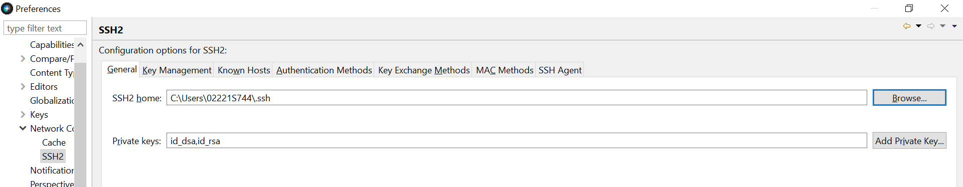

Key Management Tab:

Click on ‘Generate RSA KEY’ to generate the SSH keys.

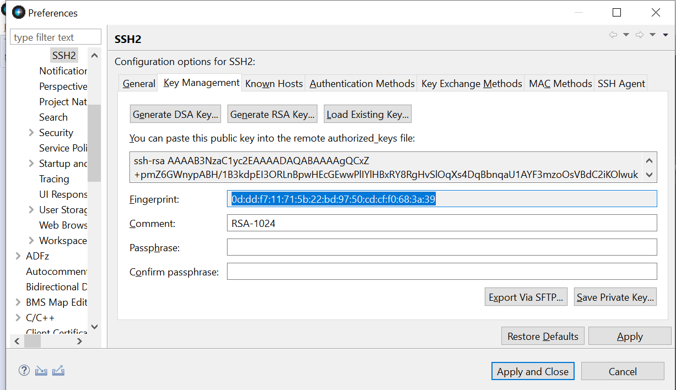

Note the finger print key. It is mentioned to fill in the details for passphrase and confirm the passphrase but it is optional.

Key: 0d:dd:f7:11:71:5b:22:bd:97:50:cd:cf:f0:68:3a:39

Comment : RSA-1024

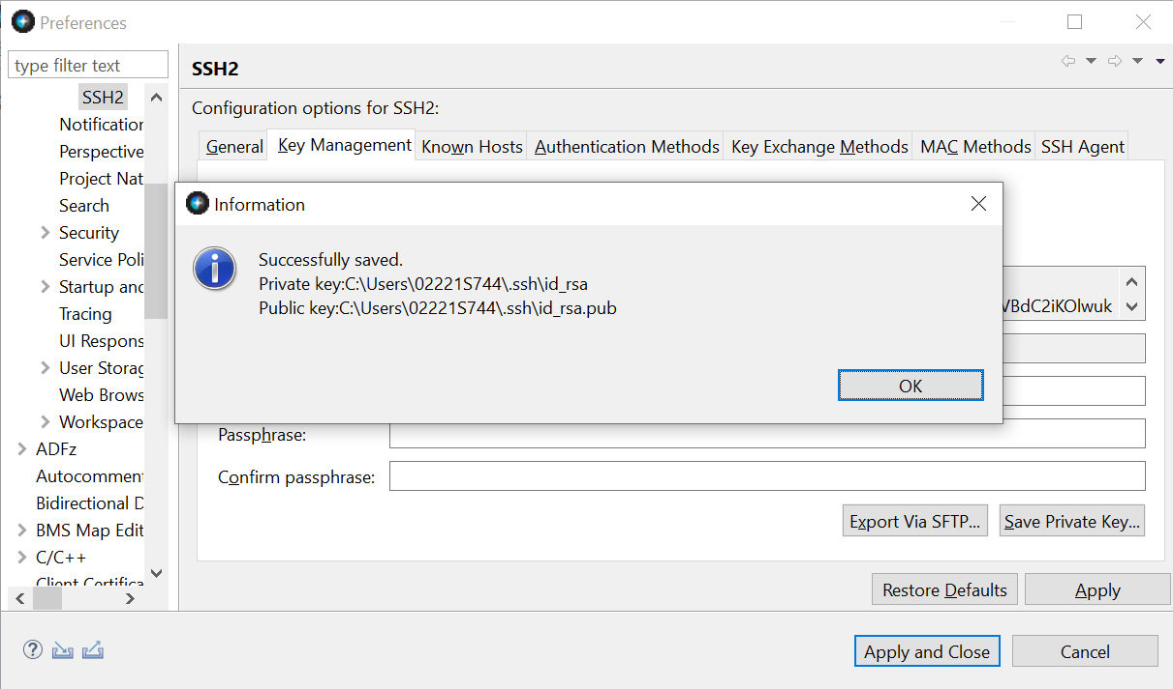

Snap shot of location:

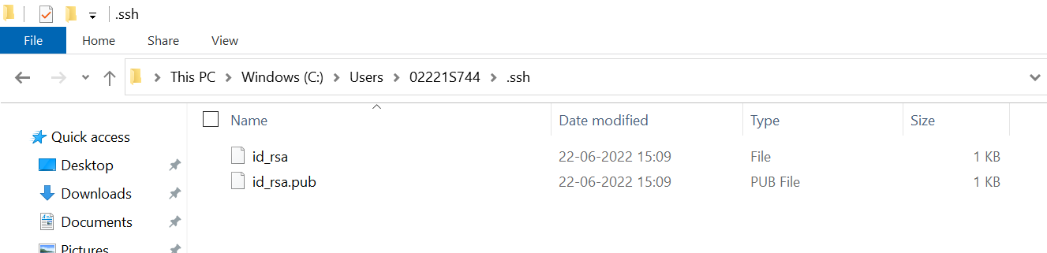

Add the generated SSH keys to your GitHub user profile on the host

Login to Github and click on settings

SSH and GPG keys:

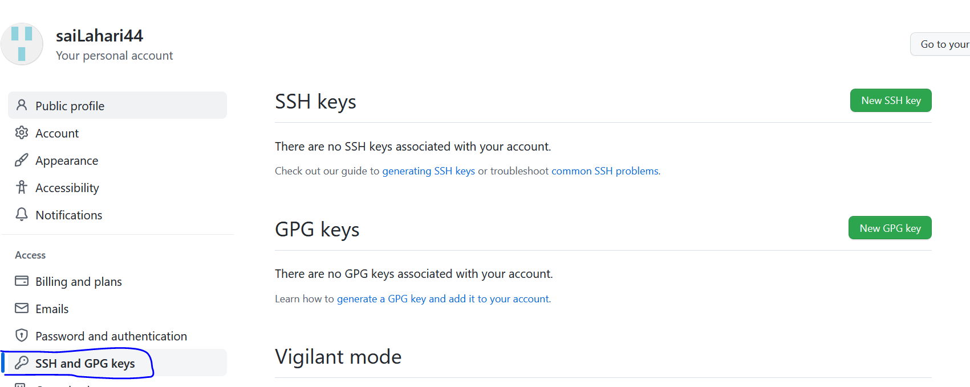

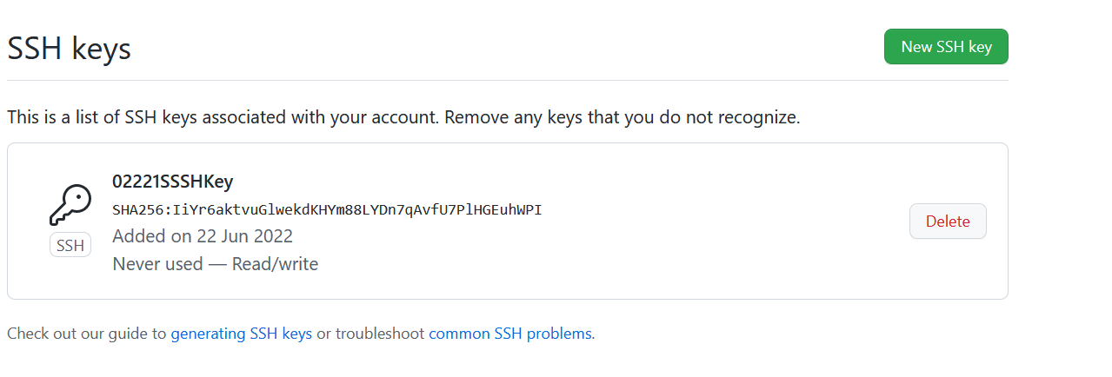

**Create the folder:**